Grassroots Powerball Program
powerballleague.com
United Powerball League
Training Manual
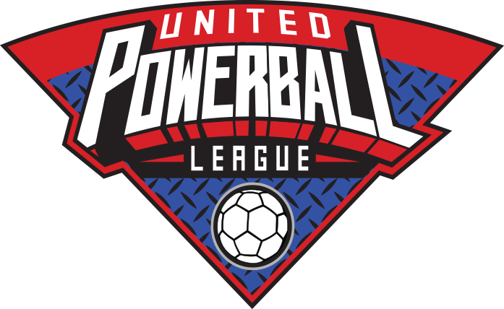

Warm Up & Stretch
The following exercises should facilitate muscle activity to prevent injury. First, make even groups with at least 6 people in each group. These groups should train as the same team throughout the practice session. Static stretching should be done prior to training, holding each stretch for about 10 seconds. Dynamic warm up should be done at half speed with the focus on preparing the body for dynamic movements. Static stretching exercises should further prepare the body for optimal movement and activity. The purpose of dynamic stretching is to prepare the body to move at full speed.
Static Stretching- Form a line with each person about 5 yards apart to allow space for stretching.
  - Jumping Jacks
  - Crossover Arm Stretch
  - Arm Circles
  - Side Lunge Stretch
  - Butterfly Stretch
  - Leg In, Leg Up, Leg Out Stretch
  - Prone Quad Stretch
  - Prone Scorpion
  - Lunge Calf Stretch

Dynamic Stretching- With the same group of people, form a line behind the person at the baseline. Walking stretches should continue for 10 yards.
  - Walking Knee to Chest
  - Walking Quad Grab
  - Walking Lunge & Twist
  - Walking High Kicks (Frankenstein)
  - Walking Toe Touch (Windmill)

Dynamic Warm Up- With the same group of people, form a line behind the person at the baseline. Warm up exercises should continue for 15 yards.
  - Light Jog and Back Peddle
  - Light Skip
  - High Knee
  - Heel Kicks
  - High Power Skip
  - Carioca
  - Side Hop Jumping Jacks
  - Full Stride Jog

Passing & Defending Warm up
Passing and Defending exercises cover the fundamentals of the sport. The warm up period should begin with groups of 2 players, and 1 handball per group. Groups should spend about 3-5 minutes on each exercise before continuing to the next variant. As the warm up period continues, different variants should be introduced that add to the previous exercise:
Passing- Players should be in groups of 2 or 3, each person standing about 10 yards apart. Players should focus on their throwing and catching technique and formation. After a few minutes of passing the ball back and forth, from 10 yards, introduce a variant of the passing exercise.
- Jog in place while passing, catching, and waiting for the pass.
- Jog forward while passing, backpedal to return to spot and receive the pass.
- Stand farther apart to increase the distance of the pass.
- Shuffle Pass to left and right side.
- Bounce Pass
Defending- Players should be in groups of 3 or 4. The exercise begins with 1 defender in the middle of the group. The group should continue passing the ball back and forth while the defender tries to contest or intercept the pass. Players should focus on defensive techniques and reacting to the pass. Introduce a variant of the exercise after each person in the group has been the defender:
- Allow the defender to make 2 hand contact with the passer before passing the ball. Groups should switch defenders when a successful defensive play is made.
- Defend or intercept the pass while the group passes the ball from about 10 yards apart. Players take turns playing defender when a successful defensive play is made.

GoalKeeper Warm up
While the goalkeeper is in goal, a group should form a line at the penalty line, each person with a ball. The group should take turns trying to shoot into the goal. Once each player shoots, they should retrieve their ball and go to the end of the line. The focus of these exercises is to develop the goalkeepers’ mobility in the goal area:
- Shoot at the top corners of the goal. The group should take alternating shots at the top left and right corners of the goal.
- Shoot at the center sides of the goal. The group should take alternating shots at the left and right sides of the goalkeeper, at the height of their hips.
- Shoot at the bottom corners of the goal. The group should take alternating shots at the bottom left and right corners of the goal.

Agility Circuit
The agility circuit is a timed exercise with different stations that help improve speed and lateral movements. Take turns at each station in the circuit. Every person in the group should complete the exercises a few times. Groups should spend no more than 5 minutes at a station before going to the next. The stations are set up in an order, or in a circle around the field. Each station should have cones and agility ladders for the various speed exercises.

Shooting Circuit
In the shooting circuit, the group should practice shooting from within and around perimeter of the penalty area. There should be 5 cones around the perimeter of the penalty area that indicate the shooting points. There should be 3 cones within the penalty area to indicate the shooting points. The group should start at one cone and proceed to the next one when everyone has shot.
- Take a running jump shot from each perimeter cone after receiving a pass from inside the penalty area.
- Take a shot at each cone inside of the penalty area after running at the cone next to it.

Group Passing Lines
The group exercises focus on team chemistry while passing the ball and defending the pass. The full group should create 3 equal lines at the baseline. The person in the middle should start with the ball at the beginning of the exercise. The group of three should complete the exercise while going from the baseline to midfield. When the entire group completes the exercise, they could repeat the exercise back to the baseline.
- From the middle line, pass the ball to the players on the left and right. Catch and pass the ball back and forth while jogging to midfield.
- Shuffle pass back and forth, to the left and right.
- “3 Man Weave”

Defending- 2 or 3 defenders should join the exercise when the group has run through the drill a few times without a defense. The group should continue the same exercises while the defenders try to stop the passes.

Scrimmage
Half scrimmage- A half scrimmage is a live-game scenario played of half of the field. The half scrimmage should be played before a full scrimmage to focus on the offense and defense in detail. The 2 teams switch offence and defense side after 1 goal is scored.

Full Scrimmage- The full scrimmage should be a practice game scenario. The group should create 2 teams using jerseys or shirts to indicate the teams. Teams can take time out for instruction and extra coaching throughout the scrimmage. Some of the official game regulations can be modified to the necessities of the game.

